# **Session play by plays**

### Session 1

Dr. Romanius has enslaved us

Dr Romaniusis a son of High Lord Sonnery

Robani is sending us on a secret mission to bring the diplomat lady ataxia to meet with another from Empress Koncosm to plot to overthrow the prince luchanns

We bury the orc baelon that romaiuns killed, recover our items then move north

There are 4 figures as we cross

1. A large scoripin
2. 2 a swarm of scarbs
3. A large shark fin

We are taking ataxia to the fallstaff manor, to attend a banquet. Apprently it has delicous food.

The toccota content is inhabited by golithes.

The first teifling is malthion

The second teifling is Ron

Ron betrayed sonnnry, but malthion stoppend him. For a reward, Ron’s decendents were made into a slave class, and malthions decendents were made into royaltay.

Ataxia is a memer of the royal family, and is considered a princess.

Ingred is a goliath that was raised by dwarves. Their family has a traditon of having the offspring fight and kill their parents then eat thier heart.

Fates most memrible kill was when his mom fought an owl bear for six hours straight, and fate put the last arrow into it. It was his first kill

We encounter a lightning charged sandworm called a carthinan wormling. It was a tough fight, and fate was downed and nearly killed (I took more then doule my hp, but we just ruled that I would go down and fail 2 death saving throughs.) dirimued was able to heal him with lay on hands, and we leveled up so we recovered to full hp and spell slots.

brinja picked up the Carthinion scale from the wormling

### Session 2

We walk through the dessert and come acros the dying sir sadore

Sadore is a knight of castora, and was hunting the great cathinging worm. He fought and wounded it, but he got mortally wounded aswell.

He gave diremuid the spark light sword, and asked him to carry on his misstion of defeating the Great worm.

We can distract enemies using meat, as shown by ingried.

The sand storm ended, so we can now walk at a normal pace through the dessert, and the land ahead is opened up to us.

We fought a sand shark, and it nearly killed diremuid, but he managed to servive thanks to the favor of lady castora. We got a sand sark fang from the courps

Fate’s patron messaged him and opened a patch of chaos realm that him and the party can use to rest outside of the elements(Lilthena’s sanctuary).

We tok a short

### Session 3

/we didnt do anything this time, we were going to start but it got cancelled I think/

### Session 4

When walking to the second area, we fought a and Elder stoneman,

After casting detect magic on the curse, Fate learned that the enslavement placed on them curse was created using Aamons power. Lilithena explains that the blood was made into gems that fit onto the dagger. Reterving more power means retreving more gems for us to use.

We also learn that is been 2 years since fate was first enslaved.

Checking the area, fate saw that there is a powerful magic to the far north, and smaller magics along the way. The magic signitures to the west is the weakest.

Tecknotep was one of the orignal followers of the forefather that was cursed. Acordding to tecknotep, the forefather puneshed the use of necromancy because the forefather created everyone to feed on later. He hated necromacy because it took his food from him. He also says there is no afterlife.

Before we were taken by the stoneman dragonborn Conrad Cosmic saved .

Luchianices is in paridisia is ruling over the new continent. The golith Empress is currently ruling gaia

### Session 5

Brinja’s brother studied under sonnery.

Her mom and and dad are neglectful af.

It seems that brinja has lost more memories then the rest of us, sonnery probably wanted to hide improtant info from us.

### Session 6

The T-rex used the acid to create 4 stone men, we faught them.

After crossing the river, we find the achnent stoneman, called lysander.

Lysander used to live here before the curse, but the forefather got him and his people. Now he is vengeful and wishs to curreput all of his people as was cursed

We fight bravely, but we get captured by him. We were forced into an illusion of our own memories

Derimud was forced to remember his past when he was sent to learn to study the sword. He feels sad about not being able to go on the pilgramage.

He goes with master ryleigh . He has a rival warrior elf quaarts who keeps insulting and dirimued shoves him him and as punishment dirimued runs 20 laps. On his first mission his company was wiiped alsmost wiped out. A beast forcesd the surviors to each other to the death, and the winner will be the slave of the beast. Dirimued was forced to fight is teacher ryhleigh. Ryleigh was happy to fight though because he thought diramued was a discrace to the order

Fate remembered when he found the cult, and managed to kill one, but the others cast some sort of spell. Fate blacked out, but then was capured by dr.rominous. Dr rommonious created the mad mage. Dr rommulis collected 5 of the powers, expet for the one held by the stonemen, and one held by one way more powerful then rommolius. He plans to find the other stones that hold the power of Amon, and take the wish for himself and making him more powerful then the sonnerys other creations. He found “slaves” to help fate find the things (probbarly the other party members)

Brinja’s brother Afric trained in magic under sonnery. Afric joined a rebels when luchionus took power. Dr rommoius turned him into a monster. Brinja had her memories of her brother complety erased when she heard the news, at her fathers request. In her memories brinja was forced to fight her brother. Alfred had been turned into a shadowbeast. but because she awakened her memories of ther brother, she was able to bring out the consiousness of her brother to reverse the control of the dreams.

After taking control of the dreams, afric destroys the ancient stoneman, and saves us from the stoneman’s curse. After we talk about the memories we lost. Then we walk to the port town to find conrad cosmic has been burnd and drained his mucles are astofied. He wakes up and yells not to go to sea in a panic. We are escorted out and we go to the docks. We meet

### Session 7

Fate and diarmuid go to the healing hut to help conrad cosmic, and they help traveling mages stablize but he does not awaken. Conrad had his very life takin and his body had been atropfied from his body. Apprently he was damaged by magic from chaos relm alled. Chaos relm is split into layers, the head mage and a dark elf mage that seems to be a lutenient. We leave and go to the docks. We meet with captan weasly thoern, a dawrf who was paid by doctor romanius to take us across the sea. He seems a little slow. After, we go shopping and buy pots, a whip, an antitoxin, and an arcane focus for fate. After shopping, ataxia suggests we split up,

Fate and ingrid went to the bar, fate was guided by the spirit of his mom towards it. After an echange with the barkeep, fate and ingrid went to talk yuaanti the lord of darkness(fromarly shaanti). He bets 4 of his fingers for his moms soul brutel chess match. but before he destroys his mom's soul, he surrenders the game so that both ingrids soul and his mom’s soul arnt destroyed. Yuaanti takes both ingrid’s soul and his mom’s soul then leaves saying the peson who will take his fingers was an old friend of his and to say hi for him. He also says that there is a soul sphere where souls go

Diarmuid goes with lady ataxia and she explains that the crow only watches fate. She has been sending messanger crows to the jagren order, and managed to get lady castora to speak with diarmuid. She explains that the forefather is neather the good nor bad, and created a cycle of reincartion of souls but igonred there suffering. She is from a long lenage that has served the forfater called the hand of the forfather. Her mother Gertrude godwyn , lead the jagron order very violently, and oppressed people. But when the forefather fell still, everyone started targeting him and the order to steal his power. Castora was 16 when she inherited the order, and lead the order down a more peaceful path. She promises to keep tabs on diarmuid and hopes that when romanious revieals his hand, they can use the info to stop his plan in its tracks.

Brynja is dragged out by one of the travelling mages. The mage girl Yona says that she sufferd a bad break up, and wants someone to talk to. Yona and brynya talk in the park. She is a member of the rune schollars. They tavel the world healling the mortally wounded. She says that whatever attacked him damaged the soul it’s self. Where yona says that when rune of her tribe use fusion rings as a form of marriage. Its a permanent fusion that they are able to preform as a combo of their rings and their regenerative abilities. Yona agreed to do the fusion marraige as a child, and now she is being called to preform it so they can heal Conrad cosmic. She isnt ready to give up her individuality. After brynja talks about her love to fight. She talks about the fights. She says fate is cool gentlemanly, and has a crazy pack.he is friendly type. Says that diramuid, who is formal, type but still gentlmenly. She is good with diramuid is good with spells. Yona says that she met a teifling that was able to make a mechanical crossbow that similer to the repeating crossbow that ingird made. After they talk a bit more, one of the mages named Sharyen Yarken, goes to bring Yona back to preform the fusion. Yona runs, and brynja follows and stops Yona from putting on the ring. Sharyen engaeds Bynja in combat. Byyngra is pushed to the brink, but before yona is forced to fuse lady castora shows up and ends the fight.

After the fight, brinja is healed, and told sharyen that she will personally help heal conrad, so yona donst have to fuse. Yona castora and sharyen leave, and diramoud, brynja ataxia catch up with fate. They all explain what happend to one ther way. At night, ataxiea and brynja go to sleep in liithna’s sanctuary, dirimued stands guard outside castroas room, and fate goes to the forest to meditate and try to use the mind stone.

### Session 8

Lady castora suggests that we were all picked by dr romanious for a purpose

Fate was picked for his affinity for the dagger of amon and his pact

Diramiud was picked for his ablity as a palidan for the jagren order

Brynja was picked for her connection to a member of the fallstaff mannor.

Lady castora knights diramuid. She gives Castora’s Gift to diramuid. If we pass the trial we can share a portion in her bloodberer powers

When a soul is taken from a body, the body dies after 24 hours, but conrad still has some portion of his soul. The roote head healer leander Harun said There was a cloth found with with the insigna of a rose vallor pirete. When two members fuse that are not of the roote clan, it isnt always disasterous if they are not incompateible. If they are combitble. The fusion will be stable. However, if one of the rings is broken, the the fusin will become unstable and begin uncontrolablely fusing with everything around it. When the second ring is destroyed, they people that conposed the fusion will be violently ripped apart, but they may servive. We are thjen

We to faildor clan to reover the fusion rings that had been sold to them, at the request of harun. We have a small fight but then the cheif interviend we were able to reson with them. We were enjoying ale and drinking with them when one of them mentioned ingried boor, and her execution at the fall staff mannor. When the mentrion of cornlious fallstaff we go berserk . romaninous makes us kill all the dwarfs, then when he comes back the says that if we mention his name or our mission to anyone, we willl be forced to kill him.he aslo forced us to kill. We picked yona to come with us. We didnt get any mony for completing the mission. When we got yona, she got branded, and fainted from the pain. we carry her to the port and Diramuid bought

A focus with the rest of the money. During the trip diramuid tried to use castora’s gift but failed. Afterwords the Rose valor pirates tried to rob us. We challanged their 2nd captian, cloven rosevalor, to a fight. He won, and but did not kill us and instead decided to honor us as fighters

### Session 9

The wayfarers wake up on the ship of the rose valor pirates, the Sea Rose. while there, they met the oher capten of the priates vastacor. We want to explore the ship a bit and we get permission to talk the prisoeners. We go there and speek with a gnome. He is raveing mad, and sayst thatThe harorld of lucionss is the won who fight conrad. She was able to absorb her power, and use it right after. She travels with the rain itself. After, we we go back to our rooms and wait for the feast to start. While in the rooms, fate uses the the mindstone power respec diramuid to put more of his ablities into charisma. After, we have a feast, and a bath. The next day we do training and we get new ablites. Diramuid became a herold of castora, and fate and brynja learned new ablites. Later in the night Diramuid woke up, and spoke with captan cloven on the top deck, they are able to see land fall. After, we are attacked by vycera the herald of lucionus and posser of one of the powers of Amon. she shatters diramuids leg and takes his sword. Cloven vastacor, fate, brynja and yona engadge her in battle. Its tough fought, but cloven goes beyond his limit to remove her from the ship. While uncontious, yuukion lord of dreams, and hiron lord of time visit diramuid in his dream. They explain that vycera , and the bloodberers is destend to be defeated by castora, then you will accend to godhood hood creating the aasmars

### Session 10

The sea rose is wrecked, but vastacor and his crew managed to get the Wayfairers. Some of the crew, and capten cloven were found dead after the attack.fate has his fingers taken by some dark fish with faces, brinja and diramuid had their armor broken, and diramuid had his. When we woke up fate, brinja, and yona tried to use castroa’s gift to become hearolds. Only yona managed to awaken the power and get the eyes of heaven. After paying out respect to the dead, and speaking with captan vastacor. He gives a rose that is able to temperally, summon him, and his sword. We make our way to fall staff mannor, and we run into the trade king of the north alaster highcastle. He explains that he is deals in trading in arms and armor, and that trade king of the South Fallstaff deals if infrastucture. The fallstaff has been the most powerful becasuse there has been a lot of destruction. The meeting here is a meeting because eveyone is tired of lucihoness’ rule and are plot against him. Highcastle also states that not everyone at the meeting is honerable and that every alliance will come with a compromise, even with him. As we go into the mannor, we have to give our weapons and armor. Fate manags to sneak his pact dagger in with him. When we go inside, and we are led the Sir Fallstaff. We are shown to our table, and we see all the other guests that had arrived. He says we will have a 3 day banquit, there will be a touriment, and a dance. We have to get 4 allicnes and a cer

### Session 11

We start with a flashback showing atxia yona and brija in the sanctuary. They have a convo, then Dr romanious showed up. He said that he did everything to train us up into strong warriors. He is nagotiontiong with sonnarys beahlf because sonnry has no idea these talks are happning. He gives us a case of new cloths, and gives us some stuff to nagotiate with. We can trade with the teccatan lands, and teccatan waters, as well as 1,000,000 gold to nagotiate with. Direamuid

### Session 12

We start off in in the great hall the moring after. Lord fallstaff, anounces that stixios fallstaff will not be partipating in the rest of the banquit and that shantelle will be handling all buissness. After, they anonce the tourniment, and that lord fallstaffs first son rickard will be the fall staff champion. While preaprign for the touniment, fate achives heroldry. After, the first fight is between jugo dex, and sir alcquin , dex lost. Second fight is between shantle rosevalor and barron herx. Shantele wins. After brinja fighst highcastle, and brinja wins. Next fight is rickered fallstaff vs sister rider elseiana. Elsianaa is a hearold of koncosum. Rickard won, and maimed elsiana. Duing the intermission, we make some alincems. Mercury is a exmpment done by the people who became the acnhent stonemen. He is a collection of darks spirits, created by necromancy. He is 1000s of years old. In the semifinals, mercury fought fate, mecury won. The fight after alquin versus rickard. After the fights, we went back to our rooms. Fate went to speak with shaantele, and wrote her memories of that night so that they had a great night together, then she agreed to a deal for 100,000 gold in aliance with scattershield,, herx, and koncosem, and sonnery. They also have a secret alliance where they will use the access they get in the alliance to investgate hearx and learn the whereabouts of the rosevalor family dragon. Then fate goes back to his room. With everyone else there. Then we get a letter and it istently transported us to a dating gameshow, hosted by gerlon, and Gotto. We all got paired with romatic instrests.   
Didi and castora, yona and brinja, baelon and ingrid, fate and lilithina, ataxia and vastacor.

### Session 13

In the moring after spending the night doing the game show and enjoying time with our loved ones, the wayfiares make their way to the great hall. Brinja is pulled aside by a knight in black armor, .Ataxia is on stage with lord fallstaff, and thye are about to announce the conditions for joining the allinace with the falstaff family. Right before they begin annouunceing the conditions, vycera walks onto the stage, and stabs ataxia in the throat. While she dies on stage, lord fallstaff explains that this is a ploy by lucianness and his herolds to round up his opposition, and slay them all together. They reviel that the food has been poisened and that the small doses throghout each of the days stacked up enough to be lethal today. While the wayfiars lay cokeing on throught due to posien, they recivie ataxias final words. Meanwhile, Brinja is in a side room with the black knight, who is reveled to be Leif, her father, and explains this whole banquit is just a conspeisy to kill the attendees. He has a antidote to the poisen, and a carage waiting outfront for bryinja and him to escape. Brynja refuses to leave without the other wayfairers, and says that she is compleled by her curse anyways. Just then, the curse compless her to stab leif because of her revelation. She levaves leif on the floor, and rushs back wtih the carage key and the antidote. When she arrives, she cures the otther wayfairs, and they begin to make their out. Ingrid stays behind to fight with koncasum. While the wayfiars run, they make their way though with much struggle as they are blocked by the knight thralls of the fallstaff manner. While they attempt theier escape, the fallstaff family slaughters everyone who remains in the hall, and try to contian Koncasum. Ingrid dies their, but koncausum breaks free, and begiens to attack the fallstaffs. Back witht he wayfairers, fate polymorphed brynja into a t-rex, and when everyone got onto her, he made a shirld to ward off most attacks. They run twards the exit, but then another black knight comes by and drops the gate, blocking the exit. Yona uses her eyes to burn a whole throught the gate. However, before they can excape, the knights manage to catch up with, the party, and knock out fate, disabling the shilds. They keep comeing up with attacks, and they manage to kill yona, and right when fate is about to meet the same end, the necklace with his moms soul in it breaks open, and floods fates body with a wave of nastagic memories with his mom, and the power he needs to contiune fighting. He has brnja gather yona’s remains, and then teleports her and himself with dimention door. Diramuid has managed to make it to outside, and is fighting the black knight. Koncosusm had fought to the best of her ablity to take down the hertrolds but she was not strong enough to beat them. When she gets rechained, she lets out a defeaning roar, whose shockwave kills the remaining, kights expet for the black kight. Diramuid seeing that he now needs to make his escape, picks up the black knights sword, then makes a dash for the carrage. The black knight tries to stop him, but with some support from fate, diramuid manages to get away. In the end though, Dr. Romanius shows up and explodes the carage. Then activates the cursemark to paralize everyone, and steal fate’s pact dagger.. Before he can get it. Leif jumps out form the window, and cuts out romainus, tempralty disbling the curse mark. He then uses the remains of the crrage to form a portal, and send sents everyone through. The wayfiarers find themselfs in a hide out of castora, and they explain the situation. In order to save yona, brynja decides to fuse with her, giving up both their indivitual existances to create bryona. Diramuid is given the spetal task to gruard castroa while she sleeps. In the meantime, fate will heal up, and beigin making preperations for the herold war that will soon breakout between sonnery, and lucianus due to this politicla insident.

# Key items

### Castora’s gift



A portion of Castora’s raw power. It is about the size of a marble, and warm to the touch. To unleash your inner potential and become a Herald of Castora, you must first discover your inner mission, and undergo a day of meditation to center yourself. Then, you must roll a 23 in your highest stat. You have three attempts per day to unlock this power, after the third failure you pass out from exhaustion.

On use, you must choose your highest stat then roll a check using it.

### Dagger powers

Shards of Amon

Dark Green- familler

White- create sanctuary

Green- curse branding

Blue- memory manipuation:with the power of the blue stone you an remember or forget your own memeores allowing you to change your stats or classes. with a weak(5hp) or willing target, you an alter thier memories.

Orange

Red

yellow

Purple

8 total

Fate:2

Vycera:1

Romanius: 5

### Layers of chaos relm

Outer layer: basic spells and wherlwind of spells

Inner layer: realm of deamons and fae

Core: uncontrollable force of magic.

# **Encountered Enemies**

[Drops](https://docs.google.com/document/d/1HZ-Tl0sKMhnQZ74Gi-VO2WBBf6MLrlezZM_ltiBQZhA/edit)

/I kinda stopped updateing this because we got the drops tab and that all i really wanted to note down, but i should update it with the new enemies we fught/

### Swarm of scarabs:

Drops: scarab meat

Exp:700

abilities

* Have a barring attack where they barrow into a target. If successful, the target will take damage overtime at the start of their turns, but they or an ally can spend an action to remove them at the cost of 1 hp. While barrowed into a crature, any attack that targets the scarabs willl also damage the creature they barrowed into.
* Resistance to nonmagical bludigening peirceing and slashing damage

Weakness:

* Vulnerable to fire

### Giant scorpian:

Drops: scorpian meat, poisen stinger,

Exp:700

Abilities:

Has 3 attacks 2 with claws and 1 with tail. Has a poisen in the tail

### Scorpian:

Drops: scorpian meat

Exp:10

Hp:1

Ablites: probably also poison

### Carthiginain wormling:

Drops: carthaginian scale

Exp:1000

Lore: the younger version of the cathiginan worm

Ablities:

* blindsight
* Can burrow into sand to move faster
* Has a recation that generates lightning when attacked with a melee attack
* Can fire 3 lighting zapps from its mouth that deal 1d40 damage. Must make a dex save of around 16 to pass for each zap.

### Carthiginain worm

The adult version of Carthiginain wormling,

Massive in size, and has strong lighting skin that shocks anyone who melee attacks it

Aslo has blindsight borrow in sand to move faster.

### Elder stoneman

* Immune to charmed condition.
* Getting bitten by one will inflect the stonecurse (just touching one will not inflicting it)

### 

### Poisunus weird

* Has a grapple that will submerge the target and block verbal componets of a spellcasting.
* Being in his body or poisen trail will deal poison damag

### Bone Naga

* Has spellcasting, and can cast 2 spells per turn
  + Spell list: command, sacred flame
* Bite attack will inflict stone curse.

### T-Rex

* Has 3 attacks, 2 tail and one bite attack.
* Its bite will inflict stoneman’s curese.

### Ancent stonemen

* Stronger then elder stonemen
* They also inflict curse with their bite

### Lysander

* One of the oldest stonemen in the wastes
* Has the power of the blue bloodstone of Amon. it grants him memory manipulation powers
* He planned to turn us into stone men, then control our bodies using a combo of his stoneman powers and the bloodstone powers.

### Cloven

* Has the power to adapt to attacks that hit him. He can become immune to an attack after it hit him.
* Has 500 hp
* Can cast disintgrate and fires 3 beams
* Attacks 3 times.

### Vycera

* Is an undead (most likely a vampire)
* Has a charm that she can activate when someone sees her eyes
* Has an armor with 500 hp, and it can regenrate after some turns.
* Can shapeshift to a degree
* Is a hearlod of luchiances.

# **NPCs**

### Lady Ataxia

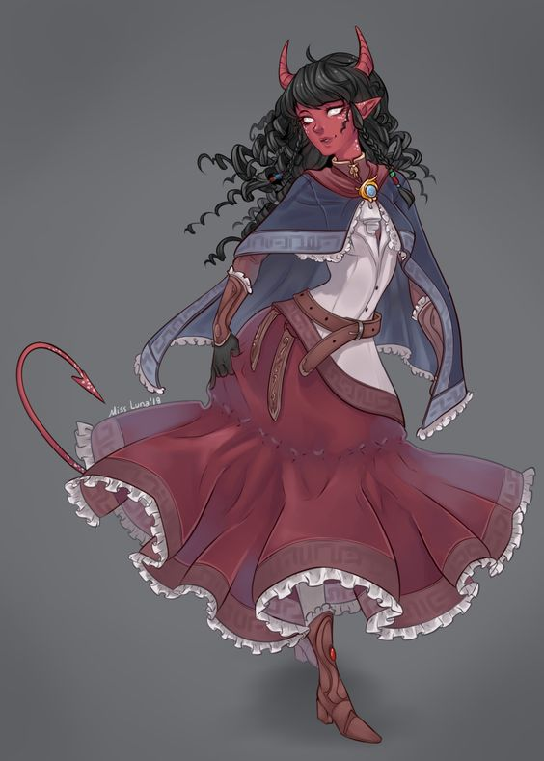

Royal tefiling created by High Lord Sonnery.

Diplomat for Sonnery making her way to the fallstaff mannor, going to meet with Empress Koncosm’s diplomant.

Dislikes Sonnery and Dr Romanius, but can not oppose them.

Has no free will of her own.

She can speak any language.

She cried for a man that she saw dying, even though she didnt know him.

Wonders what happens when we die. Fate answered(souls go to the chaos relm)

Cant handle her alcohol at al

Really likes conrad Cosmic.

Has memmores of someone else inside of her. She has no idea how old she actually is, or which memmories, are hers.

Has the ablity to send messager crows

She is from the house of malthion.

Tefilings bath in lava

Tefilings are vulnerable to salt water

### Dr. Romanius

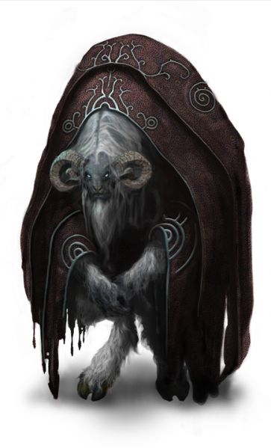

created by High Lord Sonnery.

Unlike other creations he has free will

Sonnery may be grooming him to inherit his position after he passes

Has branded us with slave seals and is watching us with a crow that has a glowing eye.

Has 5 of the 8 bloodstones of Amon. he knows where the other 3 are, aswell. He wants to take the wish for himself

Has is familier only watching Fate.

Made the soulless

### Ingrid

Ingrid is alrgic to allcohol

She has a son in the jagen order, her sons name is redgros.

Ingrid was married to the orc at the start of the game and had her son with him.

Used to be an asssion for koncosum nand raided villages.

She is 61 years old

### Conrad Cosmic,

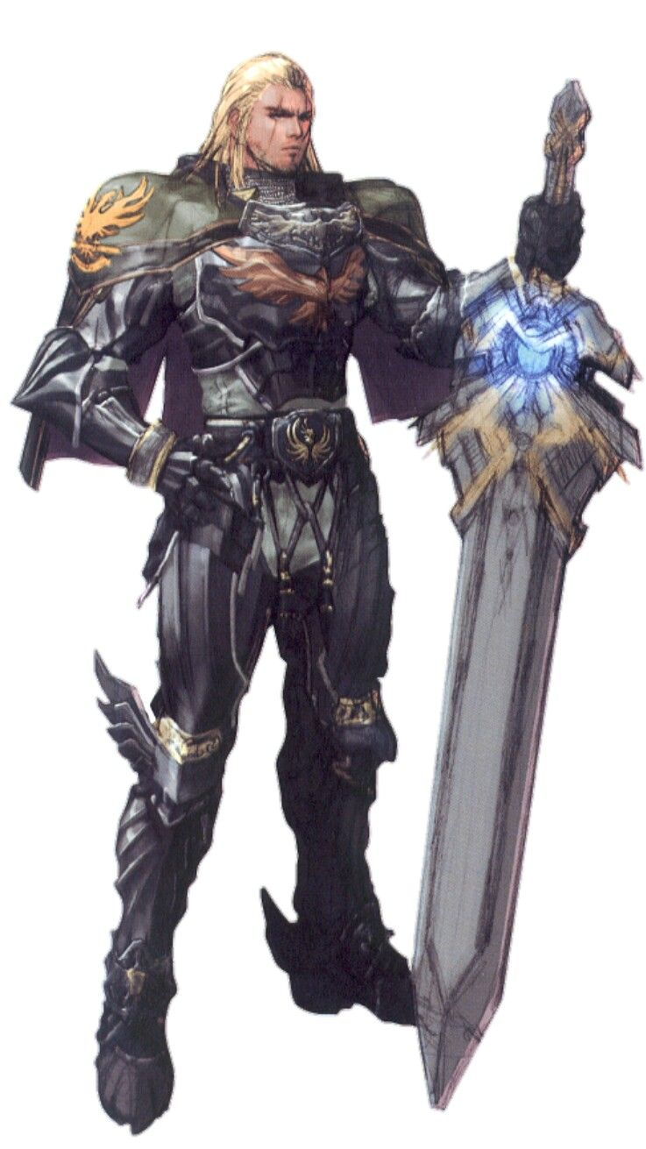

Dragonborn godcanidate that aims to fufill the prophecy,

He was a monk, that went and study with the storm sages.

He is really strong and has power over spark and flame and is able to take out

He is now traumatized of the sea because of a strong as hell monster that is there.

### Yuaanti the lord of darkness

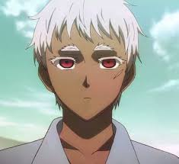

Found fate’s mom’s soul in the soul sphere

Chess player

Takes peoples fingers in bets, and has his friend come collected the debt

Probably a powerful caster, as he can manipulate souls on a high level and has deep knowlege on the chaosrelm.

Knows about Amon and what happend to him. Says it is a shame, and that Amon was really good at chess.

### 

### 

### Yona

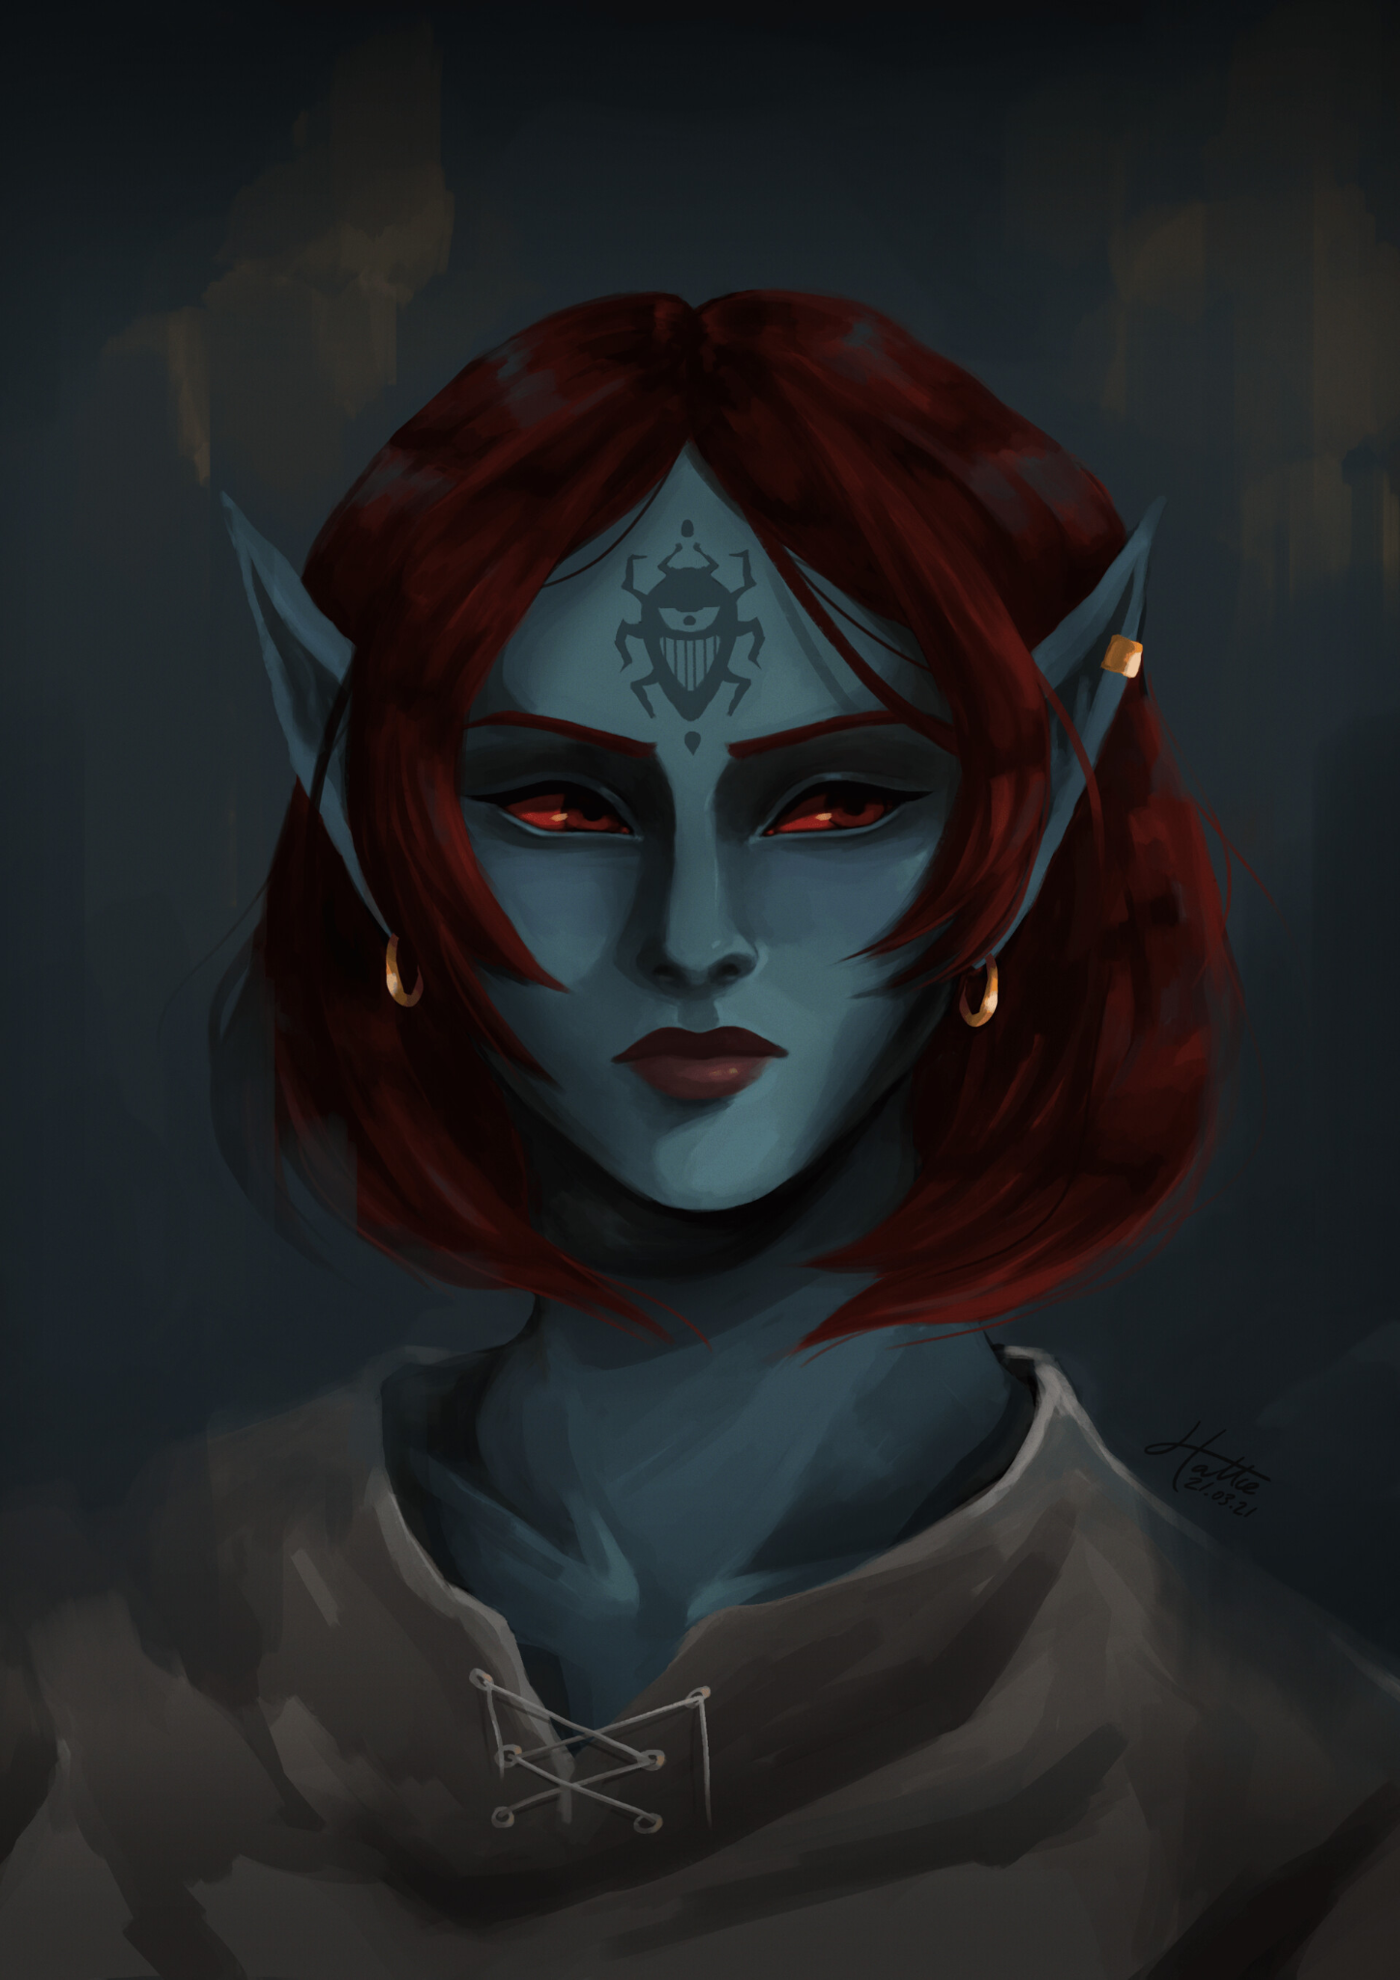

Roote schollar

She is an exprianced healer

Was promised to marry and fuse with one of the other rune schollars to ataion greatting healing power.

### Sharyen

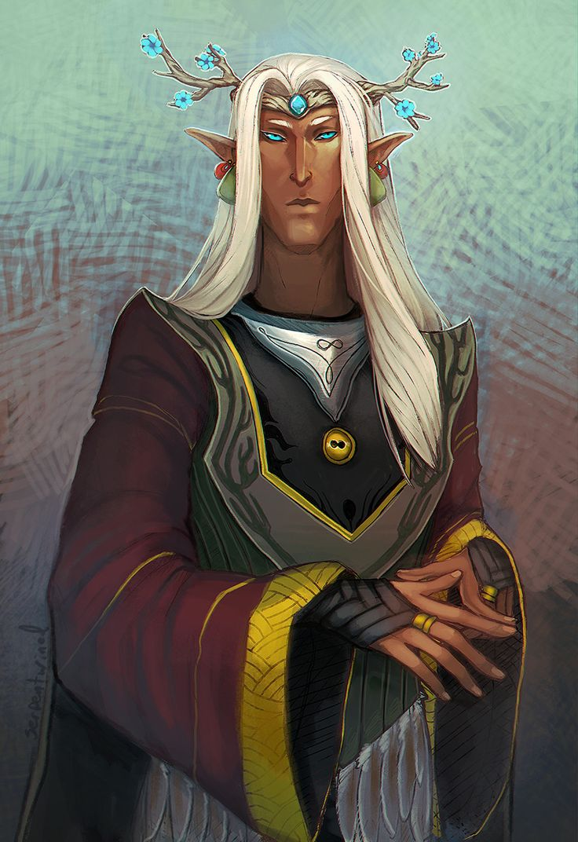

Rune schollar

Is a fusion of two other people

Wanted to fuse with Yona aswell, but got rejected.

### Lady Castora

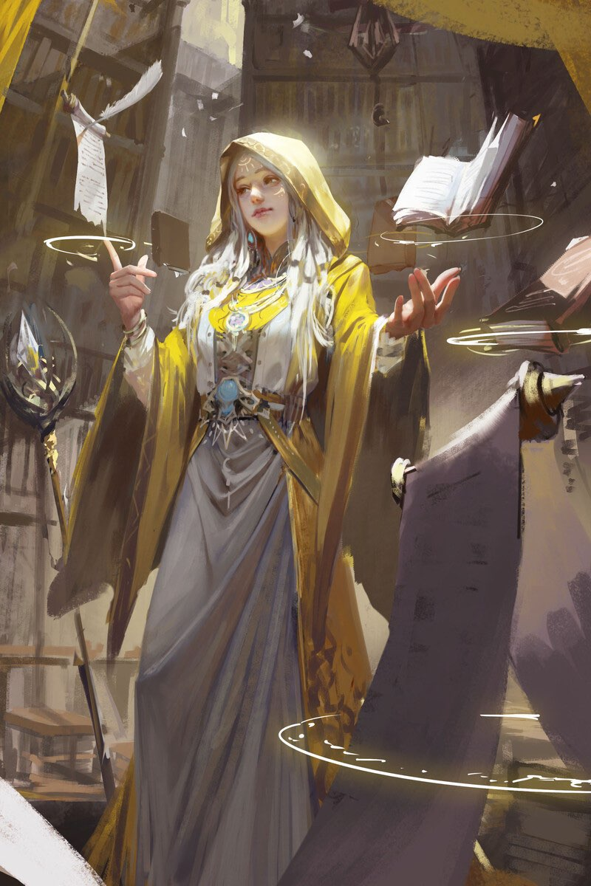

Bloodbarer

Leader of jagren order

Inertied her position from girtuded godwood

A highly skilled healer and mage,

### Lord Cornelius fallstaff

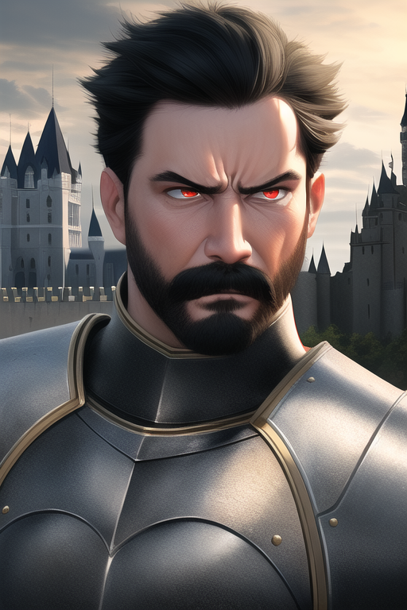

Southern trade king

Herold of lucianass

Married to vycera, father of Ricken, Jon, Jail, and Jar

### Vycera Fallstaff

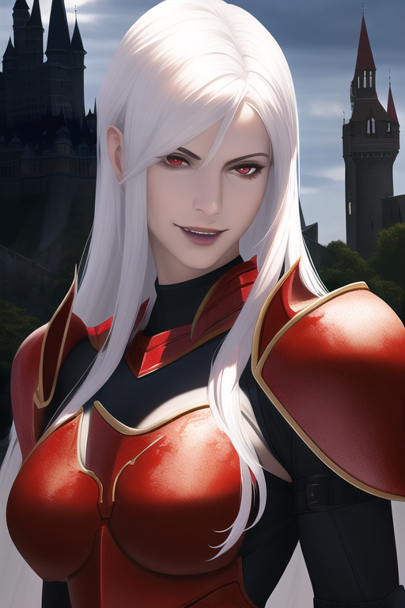

Herold of luciannas

Mairried to Lord fallstaff, mother of ricken, jon, jall, jar

Undead (vampire most likely)

Has onen of the powers of Amon

Lead the revolt against Amon.

Has the allmighty spark (now the fallen spark)

Has an armor with its own hp that can regenrate if broken.

### Rickcard Fallstaff

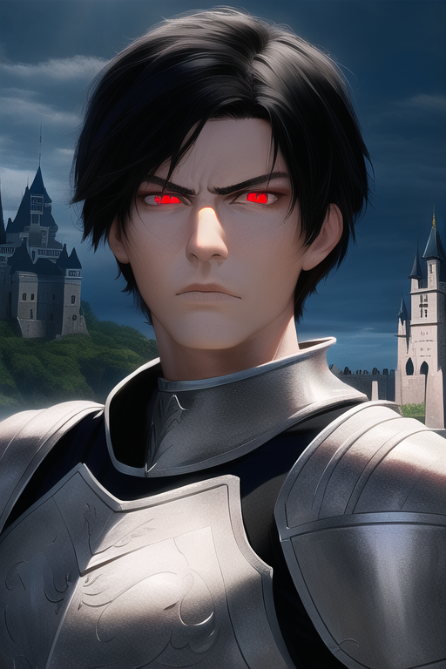

Helrold of lucianas

Herold power perfect possetion: can renaimate corpses in the area.

Son of lord fallstaff

Has a soul so black that it even chokes mercury when he uses his “Judgement Executution”